Brian Engel

Buffer Overflow Activity

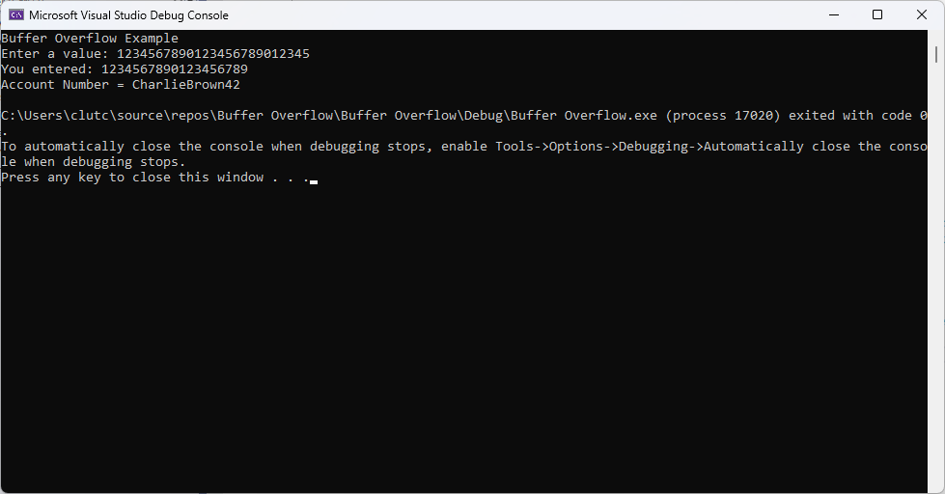

I decided to use cin.getline() to limit the number of characters that could be saved into user_input. Its first argument is the char array to be used for storage, the second argument is the number of characters that cin.getline() should read, and it has a 3rd argument that sets the delimiter, which is default to \n (newline) so we don’t need to set it. The effect is that only the first 19 characters input will be stored in user_input and a null terminator /0 in the 20th spot. Another way that could be used would be to use a string, except if that was used the input could be over 20 characters and I am under the assumption since we have an array of 20 chars it shouldn’t be longer than that.